Lesson 2 Demo 3 Images and Containers

This section will guide you to:

* Pull an image and create a new container

**Step 2.3.1:** Pulling an image

* Pull an image using the command:

*sudo docker pull nginx*

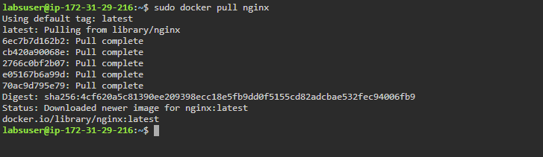

* List all the docker images to check the newly pulled *nginx* image:

*sudo docker images*

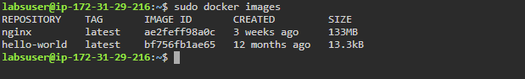

**Step 2.3.2:** Creating a new container

* Create a new container from the *nginx* image:

*sudo docker run -dt -p 80:80 nginx*



* List all the running containers to check the newly created container:

*sudo docker ps*

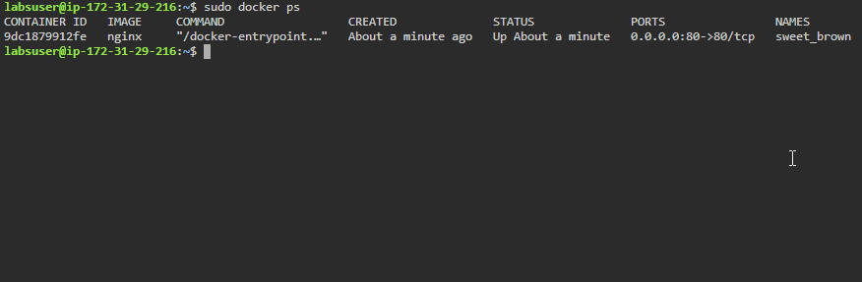

**Step 2.3.3:** Stopping the container

* Use the following command to stop the running container:

*sudo docker stop CONTAINER_NAME*

***Note:*** *Replace CONTAINER_NAME with the name of the newly created container. In this case CONTAINER_NAME is sweet_brown*

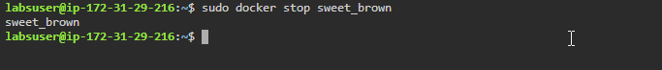

* Use the following command to list all the running containers and verify if the container has stopped running:

*sudo docker ps*

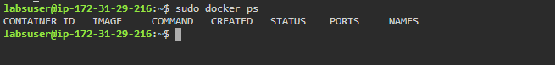

* You can start the container again and check the running containers:

*sudo docker start CONTAINER_NAME*

***Note:*** *Replace CONTAINER_NAME with the name of the newly created container. In this case CONTAINER_NAME is sweet_brown*

*sudo docker ps*

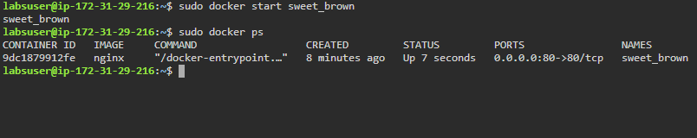

**Step 2.3.4:** Deleting the container

* Stop the running container and remove it using the following commands:

*sudo docker stop CONTAINER_NAME*

*sudo docker container rm CONTAINER_NAME*

***Note:*** *Replace CONTAINER_NAME with the name of the newly created container. In this case CONTAINER_NAME is sweet_brown*

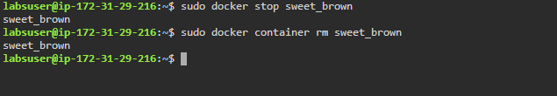

**Step 2.3.5:** Removing the image

* Remove the image using the command:

*sudo* *docker image rm nginx*

